Slide 1

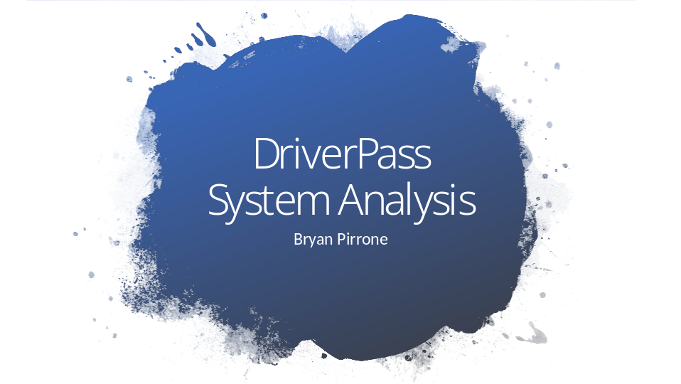

[No speaker notes required for this slide.]

Slide 2

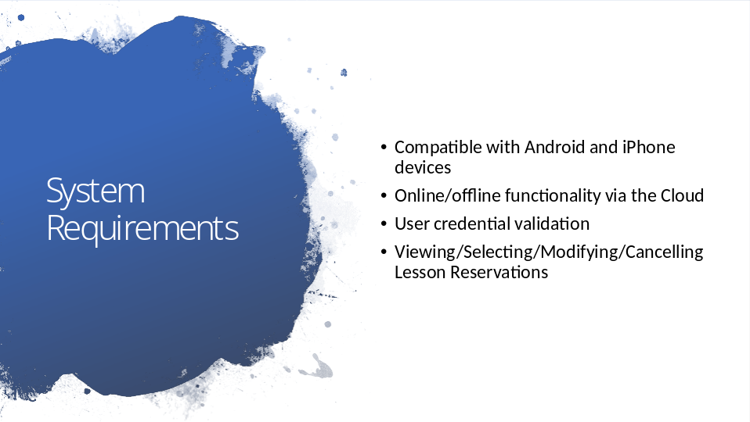

-Android/iPhone and computer access compatibility
-Online/offline functionality necessary for all users
-User account validation required in the form of Username/Password and two-factor authentication
-All users need to have the ability to view/select/modify/cancel lesson reservations

Slide 3

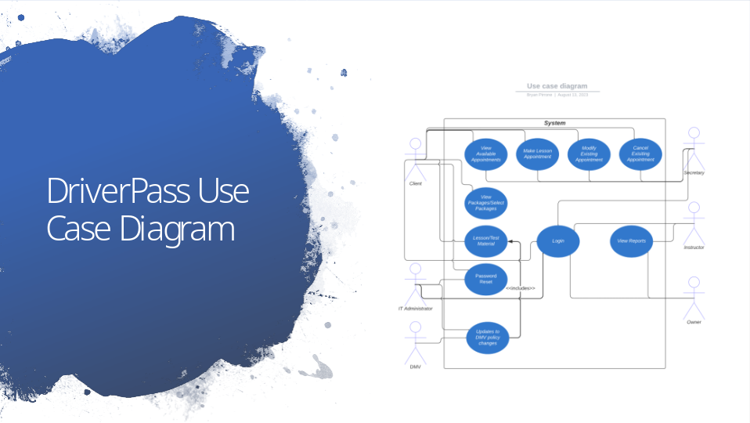

The individuals who will be interacting with the system are the client, administrator, secretary, instructors, owner, and the DMV.

All users will need to log in to access their account-specific information. User accounts will be role-specific based on their interactions with the system.
Clients will be able to view and select available packages, view/make/change/cancel lesson appointments, access lesson/test material, and reset their passwords.
The administrator will be able to reset passwords, remove individuals from the system, and ensure roles are properly assigned.
The DMV will be synchronized with the system to ensure policy updates get incorporated into study materials.
The secretary will have the ability to assist with the scheduling, modification, and cancellation of driving lessons.
The instructors will be able to view/edit reports and access the master schedule.
The owner will be able to view reports about the schedule and see who edited it last.

In order to integrate the goal of DriverPass into the system, we had to include all of this functionality with respect to an individual’s interaction with the system.

Slide 4

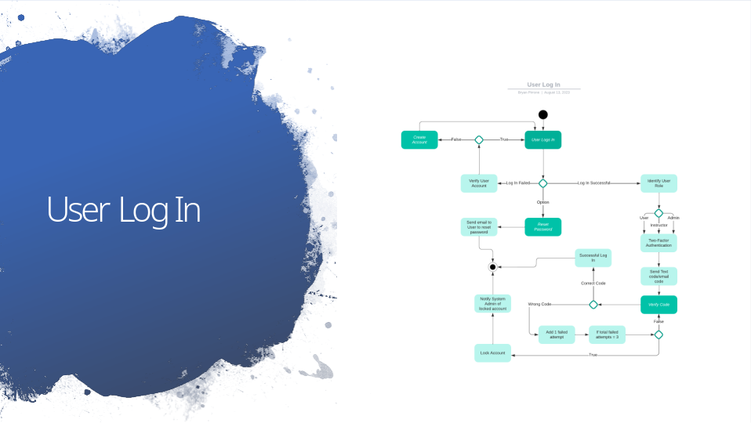

This activity diagram depicts how any user of the system would log in.

The user will attempt to log in or create a new account. If the individual forgot their password, they will be allowed to reset it by sending a link to their registered email address for their account. If the login failed, they would have several attempts to re-enter their password. Once the correct username/password is entered and verified, the user’s role will be identified. Two-factor authentication will require that an emailed code be entered successfully. If the code is successfully entered, then the user will be granted access to the system. If the code is not successfully entered, the individual will be given three attempts to enter the correct code prior to the account being locked out. Once the account is locked out, the system administrator will be notified of the lock-out.

DriverPass needs a form of login verification for security purposes. This process helps to ensure that unauthorized access is minimized.

Slide 5

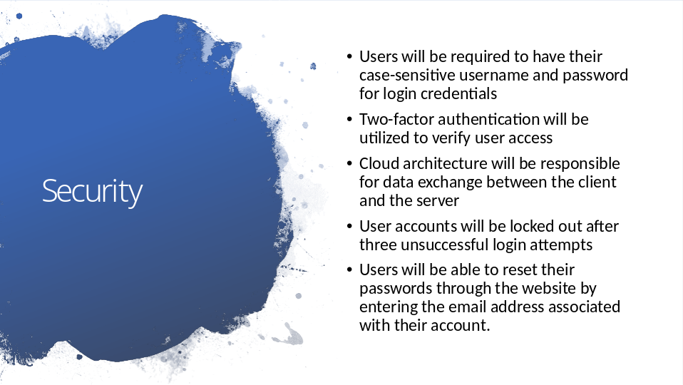

Security is a necessary component for the fidelity of the system. It helps to ensure that personal information is protected, unauthorized access is denied, and malicious and inadvertent actions are prevented. Since personal and business information will be on the website, protecting this information is vital.

Slide 6

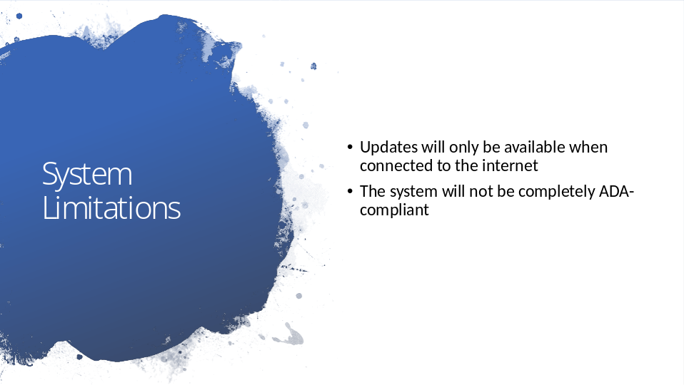

For an individual to access new, updated information in the system, they will need to be able to access the internet. While offline functionality exists, it is solely for the data that is present at the time of the download.

The system will not be completely ADA-compliant. The system isn’t designed currently to support blind individuals.

